Bacteria
Bacteria are single celled microbes. The cell structure is simpler than that of other organisms as there is no nucleus or membrane bound organelles. Instead their control centre containing the genetic information is contained in a single loop of DNA. Some bacteria have an extra circle of genetic material called a plasmid. The plasmid often contains genes that give the bacterium some advantage over other bacteria. For example it may contain a gene that makes the bacterium resistant to a certain antibiotic.
Bacteria are classified into 5 groups according to their basic shapes: spherical (cocci), rod (bacilli), spiral (spirilla), comma (vibrios) or corkscrew (spirochaetes). They can exist as single cells, in pairs, chains or clusters.
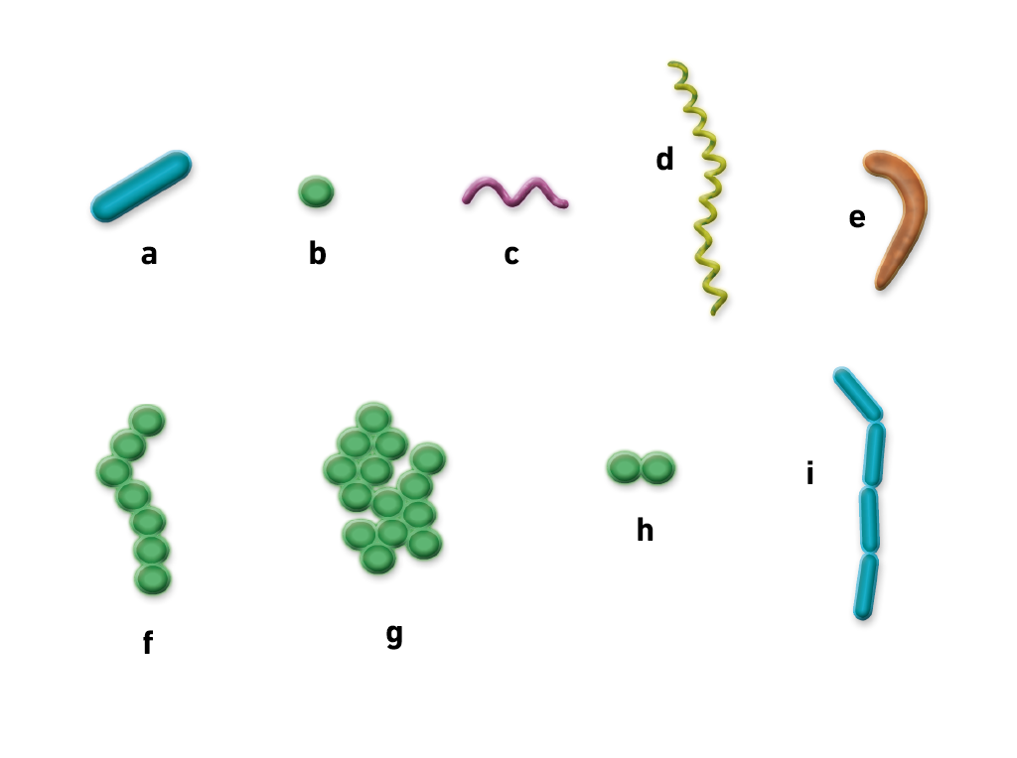
The different bacterial shapes:
a. bacillus (rod), b. coccus (spherical), c. spirillum (spiral), d. spirochaete (corkscrew), e. vibrios (comma), f. chain of cocci, g. cluster of cocci, h. pair of cocci, i. chain of bacilli

Bacteria are found in every habitat on Earth: soil, rock, oceans and even arctic snow. Some live in or on other organisms including plants and animals including humans. There are approximately 10 times as many bacterial cells as human cells in the human body. A lot of these bacterial cells are found lining the digestive system. Some bacteria live in the soil or on dead plant matter where they play an important role in the cycling of nutrients. Some types cause food spoilage and crop damage but others are incredibly useful in the production of fermented foods such as yoghurt and soy sauce. Relatively few bacteria are parasites or pathogens that cause disease in animals and plants.

How do bacteria reproduce?
Bacteria reproduce by binary fission. In this process the bacterium, which is a single cell, divides into two identical daughter cells. Binary fission begins when the DNA of the bacterium divides into two (replicates). The bacterial cell then elongates and splits into two daughter cells each with identical DNA to the parent cell. Each daughter cell is a clone of the parent cell.
When conditions are favourable such as the right temperature and nutrients are available, some bacteria like Escherichia coli can divide every 20 minutes. This means that in just 7 hours one bacterium can generate 2,097,152 bacteria. After one more hour the number of bacteria will have risen to a colossal 16,777,216. That’s why we can quickly become ill when pathogenic microbes invade our bodies.

Survival mechanism
Some bacteria can form endospores. These are dormant structures, which are extremely resistant to hostile physical and chemical conditions such as heat, UV radiation and disinfectants. This makes destroying them very difficult. Many endospore-producing bacteria are nasty pathogens, for example Bacillus anthracis is the cause of anthrax.
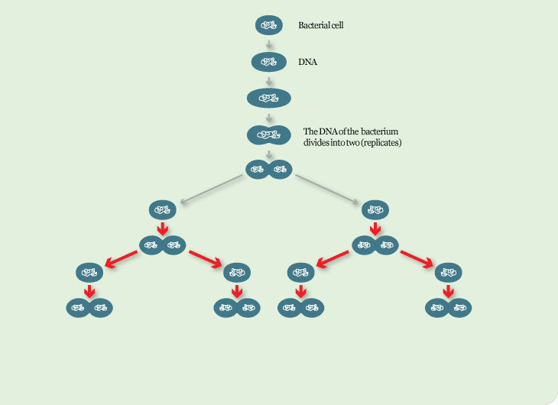
Reproduction through Binary Fission
One becomes two ... two becomes four ... four becomes eight
This means in 8 hours, the number of bacteria will have risen to a colossal 16,777216!

Cholera - General Information
Below you will find answers to commonly asked questions about cholera.

Frequently Asked Questions
What is cholera?
Cholera is an acute, diarrheal illness caused by infection of the intestine with the toxigenic bacterium Vibrio cholerae serogroup O1 or O139. An estimated 2.9 million cases and 95,000 deaths occur each year around the world. The infection is often mild or without symptoms, but can sometimes be severe. Approximately one in 10 (10%) infected persons will have severe disease characterized by profuse watery diarrhea, vomiting, and leg cramps. In these people, rapid loss of body fluids leads to dehydration and shock. Without treatment, death can occur within hours.
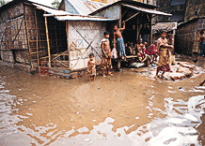
Where is cholera found?

The cholera bacterium is usually found in water or food sources that have been contaminated by feces (poop) from a person infected with cholera. Cholera is most likely to be found and spread in places with inadequate water treatment, poor sanitation, and inadequate hygiene.
The cholera bacterium may also live in the environment in brackish rivers and coastal waters. Shellfish eaten raw have been a source of cholera, and a few persons in the U.S. have contracted cholera after eating raw or undercooked shellfish from the Gulf of Mexico.
How does a person get cholera?
A person can get cholera by drinking water or eating food contaminated with the cholera bacterium. In an epidemic, the source of the contamination is usually the feces of an infected person that contaminates water and/or food. The disease can spread rapidly in areas with inadequate treatment of sewage and drinking water. The disease is not likely to spread directly from one person to another; therefore, casual contact with an infected person is not a risk for becoming ill.
What are the symptoms of cholera?
Cholera infection is often mild or without symptoms, but can sometimes be severe. Approximately one in ten (10%) infected persons will have severe disease characterized by profuse watery diarrhea, vomiting, and leg cramps. In these people, rapid loss of body fluids leads to dehydration and shock. Without treatment, death can occur within hours.
How can I avoid getting cholera?

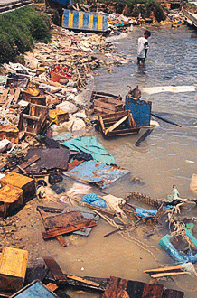
The risk for cholera is very low for people visiting areas with epidemic cholera. When simple precautions are observed, contracting the disease is unlikely.
All people (visitors or residents) in areas where cholera is occurring or has occurred should observe the following recommendations:
- Drink only bottled, boiled, or chemically treated water and bottled or canned carbonated beverages. When using bottled drinks, make sure that the seal has not been broken.
  - To disinfect your own water: boil for 1 minute or filter the water and add 2 drops of household bleach or ½ an iodine tablet per liter of water.
  - Avoid tap water, fountain drinks, and ice cubes.
- Wash your hands often with soap and clean water.
- If no water and soap are available, use an alcohol-based hand cleaner (with at least 60% alcohol).
  - Clean your hands especially before you eat or prepare food and after using the bathroom.
- Use bottled, boiled, or chemically treated water to wash dishes, brush your teeth, wash and prepare food, or make ice.
- Eat foods that are packaged or that are freshly cooked and served hot.
  - Do not eat raw or undercooked meats and seafood, or raw or undercooked fruits and vegetables unless they are peeled.
- Dispose of feces in a sanitary manner to prevent contamination of water and food sources

Superbugs: What are they and how are they treated?
The World Health Organisation is warning new antibiotics urgently need to be developed to combat 12 families of bacteria posing a threat to human health.

Superbugs who tease
The WHO said many of the bacteria have evolved into superbugs that are resistant to antibiotics.
The health agency said governments need to invest in research if new drugs are to be found in time to control the superbugs, as market forces do not respond fast enough to the threat.
Professor Penelope Bryant, an honorary fellow in infection and immunity at the Murdoch Children's Research Institute, said government investment would not be enough.
"It costs a lot of money to develop a drug, so the WHO releasing this list of urgent priority bugs is an important call to action to develop new antibiotics to prevent more deaths," she said.
"As important as new antibiotics are, to stop the rise in resistant infections we need to do more. We need to stop the spread of infections and we need to preserve our current antibiotics by using them better."
So what is the scope of the superbug issue? And how do we better use our antibiotics to stop the rise of superbugs?

What is a superbug?
Superbugs are strains of bacteria that have adapted after coming into contact with an antibiotic.
Once this happens, these bacteria become "resistant" the to antibiotic to which they have been exposed, which means the antibiotic cannot kill the bacteria or stop them from multiplying.
So you end up with bacteria in effect equipped with "bulletproof vests" that deflect our "magic silver bullets" of antibiotics.
It is worth noting not all bacteria are bad, they are everywhere and are mostly harmless. Some are quite helpful. Others can cause illness.
We can often recover from bacterial illnesses with no treatment, such as minor skin or ear infections. But sometimes these illnesses are deadly, for instance meningitis or pneumonia, making treatment with antibiotics essential.

How does it happen?
Overusing antibiotics is a major cause of antibiotic resistance, as is incorrectly taking antibiotics you have been prescribed.
Studies have found one packet of antibiotics can affect the level of drug-resistant bugs in your own body and can also contribute to the broader issue of antibiotic-resistant disease at a community level.
After just one course of antibiotics, the risk of having antibiotic-resistant organisms increases by roughly 50 per cent.
At an individual level, when you take antibiotics it is not just the bacteria making you sick that are affected.
For example, when you take antibiotics for a urinary tract infection, these can impact on bacteria in other parts of your body, such as your gut or your nose.
Sometimes these bacteria are part of your body's natural defences to bacterial infection — like the good bacteria in your gut.
This can then make you more susceptible to antibiotic-resistant bacteria spread by other people.

Overuse in Australia
According to the Australian Commission on Safety and Quality in Healthcare, Australia has a higher rate of antibiotic use when compared to similar countries, such as Canada and the United Kingdom.
In 2014, 46 per cent of Australians were supplied with at least one antibiotic.
But it is not just humans who are being dosed. Agricultural antibiotic use is also a contributing factor, with the human consumption of antibiotic-treated chicken and livestock further increasing resistance.

Should we be worried?
The World Health Organisation has identified antibiotic resistance as one of the greatest threats to human health today.
A UK Government review into antimicrobial resistance commissioned in 2014 found that if left untreated, antibiotic resistance could lead to 10 million deaths a year worldwide by 2050 — costing the world roughly $1.3 trillion.
One of the main types of multi-resistant organisms found in Australia are the bugs that cause staph infections, which can be found both in hospitals and in the community.
But fortunately, so far Australia has managed to avoid some of the other superbugs that have become prevalent overseas.
One type of superbug Australia has managed to keep under control is multidrug-resistant tuberculosis.
Once considered manageable with antibiotics, drug-resistant strains are on the rise again in developing nations, particularly in sub-Saharan Africa.
But superbugs have even become an issue in developed countries like the United States, where some types of multi-resistant bacteria are a bigger problem than in Australia.

Superbugs your decisions
In a hospital environment, doctors use antibiotics for a variety of reasons — and not just to treat patients who presented with infections.
For instance, people having surgery, such as hip or knee replacements, are given antibiotics to prevent or treat infections.
One big worry with superbugs is that if doctors do not have antibiotics at their disposal, things like hip replacements are suddenly much more dangerous than they would otherwise be.

How many superbugs are there?
The WHO said there were 12 "priority pathogens" posing a significant risk to human health, some of which have already evolved into superbugs. The list is divided into "critical", "high", and "medium" priorities, based on how urgent the need for new antibiotics to treat the bug is.
The critical group includes multidrug-resistant bacteria that pose a particular threat in hospitals, nursing homes, and other care facilities.

Antibiotics use in Agriculture
There’s growing concern about the use of antibiotics in the animal industry and agriculture.
Australia imports about 7 hundred tonnes of antibiotics annually. More than half of that goes into stock-feed, about 8% is for veterinary use, leaving only one-third for human use.
Antibiotics & Agriculture
Antibiotics are used widely in food animals as growth promoters and to prevent and treat infection. Avoparcin, a glycopeptide related to the human last line drug Vancomycin, is used in Australia as a growth promotant in pigs, chickens and feedlot cattle. Virginiamycin is used as a growth promotant but also for treating resistant human bacteria.
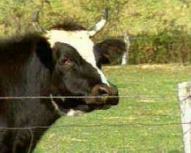
As well as oral administration and injection of antibiotics, small amounts are mixed into animal feed for weeks or months at a time. Feed dosing provides ripe conditions for the emergence of resistant strains.
Antibiotics are also sprayed onto fruit trees to prevent and treat infection. Traces of antibiotics that remain after the initial spraying may encourage emergence of resistant strains of bacteria. During spraying the wind can spread low concentrations of the antibiotic further afield, possibly increasing the risk of resistant bacteria. In both cases, it is possible for antibiotic resistant bacteria to enter the food chain, ultimately reaching humans.
Transferral of resistant bacteria to humans
There is a growing body of evidence that antibiotic resistant bacteria are transferred to humans. In 1997, the World Health Organisation’s report on ‘The medical impact of antimicrobial use in Food Animals’ highlighted several cases where transfer of resistance from animals to humans had occurred. It can happen through: direct contact with animals; the consumption of meat; drinking contaminated water or the transfer of genes between animal and human bacteria.
A 1998 review of literature by Australia’s JETACAR committee also concluded that resistant animal bacteria did transfer to humans and cause disease. Antibiotic resistant genes also spread from animal bacteria to human pathogens.
It is the gut bacteria or ‘tummy bugs’, rather than the killer bacteria, like pneumonia, which transfer in this way. However, E.coli and Salmonella, which can be transmitted through food or direct contact with animals, are deadly in some circumstances.
Consequences
This transferral of resistance is having an effect. The UN reported that, after the introduction of the fluoroquinolone antibiotics for use in food animals, strains of Salmonella with decreased susceptibility to this class of antibiotics were found in humans in France, Germany, Ireland, the Netherlands, Russia Federation, Spain and the United Kingdom.
The emergence of vancomycin-resistant Enterococcus (VRE) may also be related to the use of Avoparcin as an animal growth promoter. "There is fairly convincing evidence in Europe that the VRE germ probably developed in animals, pigs and chickens in particular, and this was acquired by the general population through the food chain," says Associate Professor Collignon. The European Union's suspension of the use of Avoparcin, pending further inquiries, lead manufacturer Roche to end production of the antibiotic. Roche cited a lack of market access as making Avoparcin no longer economic. Curiously, Australian agriculture does use Avoparcin extensively, but the most common VRE identified, doesn't appear to be connected to its use.
A review of the use of Avoparcin in Australia by the Agricultural and Chemical Registration body, the National Registration Authority (NRA) was suspended in January 2000, when Roche announced that Avoparcin stocks were running out. In the past the NRA has put extensive restrictions on the use of another widely used animal antibiotic known colloquially as Pen-Strep, mainly because of residue levels in meats.

Bacterial Disease questions worksheet:
- Food poisoning can also cause severe gastrointestinal (digestive) issues due to certain bacteria. Explain why this can happen and how to avoid it (refer to the nature of the division of bacteria, where the can survive, and describe some healthy food handling processes) (5 marks)
_______________________________________________________________________________________________
_______________________________________________________________________________________________
_______________________________________________________________________________________________
_______________________________________________________________________________________________
_______________________________________________________________________________________________
_______________________________________________________________________________________________
_______________________________________________________________________________________________
_______________________________________________________________________________________________
_______________________________________________________________________________________________
_______________________________________________________________________________________________
_______________________________________________________________________________________________
_______________________________________________________________________________________________

- Create a venn diagram below comparing cholera to food poisoning (symptoms, causes, prevention etc.)

- Describe how antibiotic-resistant strains of bacteria are created (refer to evolutionary processes) (3 marks)
_______________________________________________________________________________________________
_______________________________________________________________________________________________
_______________________________________________________________________________________________
_______________________________________________________________________________________________
_______________________________________________________________________________________________
_______________________________________________________________________________________________
_______________________________________________________________________________________________
_______________________________________________________________________________________________
_______________________________________________________________________________________________
_______________________________________________________________________________________________
_______________________________________________________________________________________________

- Describe 3 consequences on a community or public health level that arise from over-use of antibiotics (3 marks)
_______________________________________________________________________________________________
_______________________________________________________________________________________________
_______________________________________________________________________________________________
_______________________________________________________________________________________________
_______________________________________________________________________________________________
_______________________________________________________________________________________________
_______________________________________________________________________________________________

- Describe one problem specific to the over-use of antibiotics in agriculture (2 marks)

_______________________________________________________________________________________________
_______________________________________________________________________________________________
_______________________________________________________________________________________________
_______________________________________________________________________________________________
_______________________________________________________________________________________________
_______________________________________________________________________________________________
_______________________________________________________________________________________________

